Policies and Procedures
Medication Requests
It is important for you to keep your appointment to ensure proper medical treatment. However, Revive Psychiatry understands at times there will be a need for you to reschedule your appointment. Revive Psychiatry reserves the right to not call in medications for you when you miss, cancel, or reschedule your originally scheduled appointment and not fill medications until you are seen again. It is important for your provider to evaluate your progress and side effects before refilling your medications. When rescheduling your appointment, you will be scheduled on the next available appointment. If medications are called in to sustain you until your next appointment, you are responsible for a $20 administrative fee for processing the refill request. This fee will not be billed to your insurance company and the fee must be paid to complete the medication refill request. Under NO circumstances will controlled substances be called in because of a missed appointment and you must see a provider prior to renewal.

Late Arrivals/Missed/Cancelled Appointments
It is important to for you to make every attempt to come to your scheduled appointment on time. Your appointment has been scheduled so follow-up and adjustments can be made to your treatment plan. If you are more than 15 minutes late to a scheduled appointment Revive Psychiatry reserves the right to require a new appointment be scheduled. If you will need to cancel an appointment, please do so as soon as possible. We request a 24-hour notice to cancel an appointment, but we do understand that things will come up. Any appointment canceled prior to 24 hours of the appointment time will not be charged a No-Show Fee. Any appointments canceled less than 24 hours before the scheduled appointment will incur a No-Show Fee. The first No Show charge is $50. Any subsequent No Shows will result in a $100 charge. These charges are due at the time your next service is rendered, in addition to any copays/coinsurance you are required to pay.

Miscellaneous Forms
Short- and Long-Term Disability, FMLA, Questionnaires, Assessments, Narratives, etc. Revive Psychiatry is a private practice that charges fees for services. Completion of forms and requests for letters are often not covered by your insurances. Therefore, the responsibility of paying for the request is the patient’s responsibility. When you request completion of any forms, letters, questionnaires, assessments, narratives, etc. you must submit a request form and payment is due at the time of the request. The request will not be processed until payment is made. All attempts to complete the request prior to the requested completion date on the forms will be made but can take up to 10 business days. Once the request is completed, our office will contact you with additional information. By signing this portion, you agree to these terms for future references.

A list of Administrative Fees are included below.
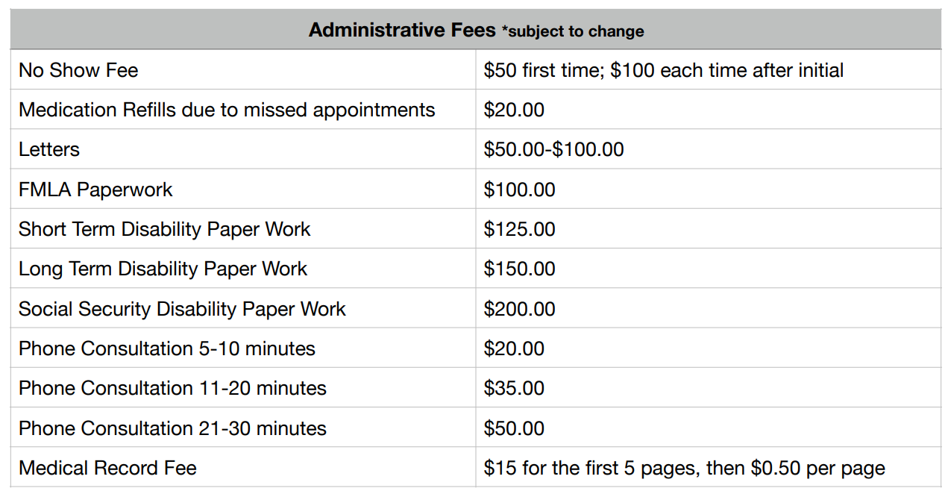
Benefits and Risks of Therapy
Therapy is an interactive process to promote change and understanding between the patient and the provider(s). Therapy can be emotionally painful but can also be fulfilling. You will be expected to distribute all decisions regarding the interventions and treatment plans advised for you, including out of session tasks, laboratory services, and urine drug screens. You have the right to refuse or alter any intervention or services. You should question the reason for treatment if you do not fully understand what it entails. While our goal is to help you identify and achieve therapeutic goals, we cannot guarantee any specific outcome. Revive Psychiatry does not offer 24-hour answering services. In the event you have a need for services after regularly scheduled business hours, on holidays, or when the office is closed, please call 9-1-1 or go to your nearest emergency room. You may also contact The Suicide Prevention Hotline at 1-800-273-8255.

